Student Name: Harmanpreet Kaur
Student id: 991855668
Lab 4 Working with Excel

GitHub repository:

Introduction: In this lab, I used the ImportExcel module in PowerShell to work with Excel files without needing Microsoft Excel installed on my computer. This document includes the commands I used, screenshots of the commands and their outputs, and a short explanation of each step. I have also included notes about what I observed from the output and a reflection at the end about what I learned from the lab.
Step 1: Install the ImportExcel module
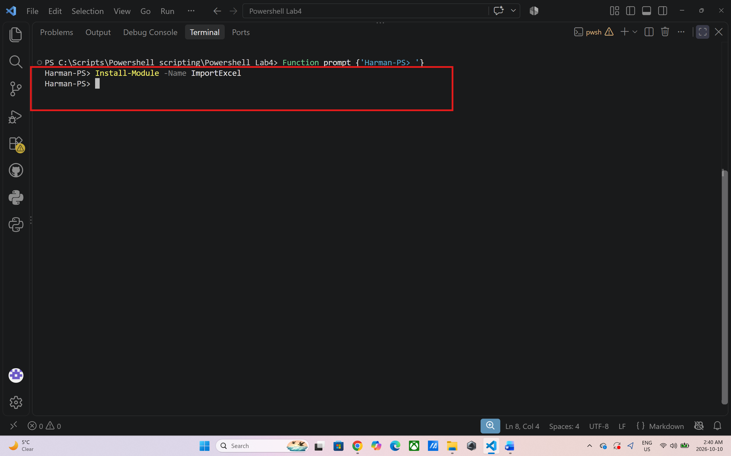
Output: This command downloads and installs the ImportExcel module from the PowerShell gallery. This module gives me command such as Import-Excel and Export-Excel that I use to read and write excel files. What I like about this module is that it does not need Microsoft Excel. It reads and writes the excel file directly, so I can put it on a server without installing Microsoft Office there. I ran command Install-Module -Name ImportExcel and I didn’t get any red error, so it means this command worked.

Step 2: Copy Fruits .xlsx to the server
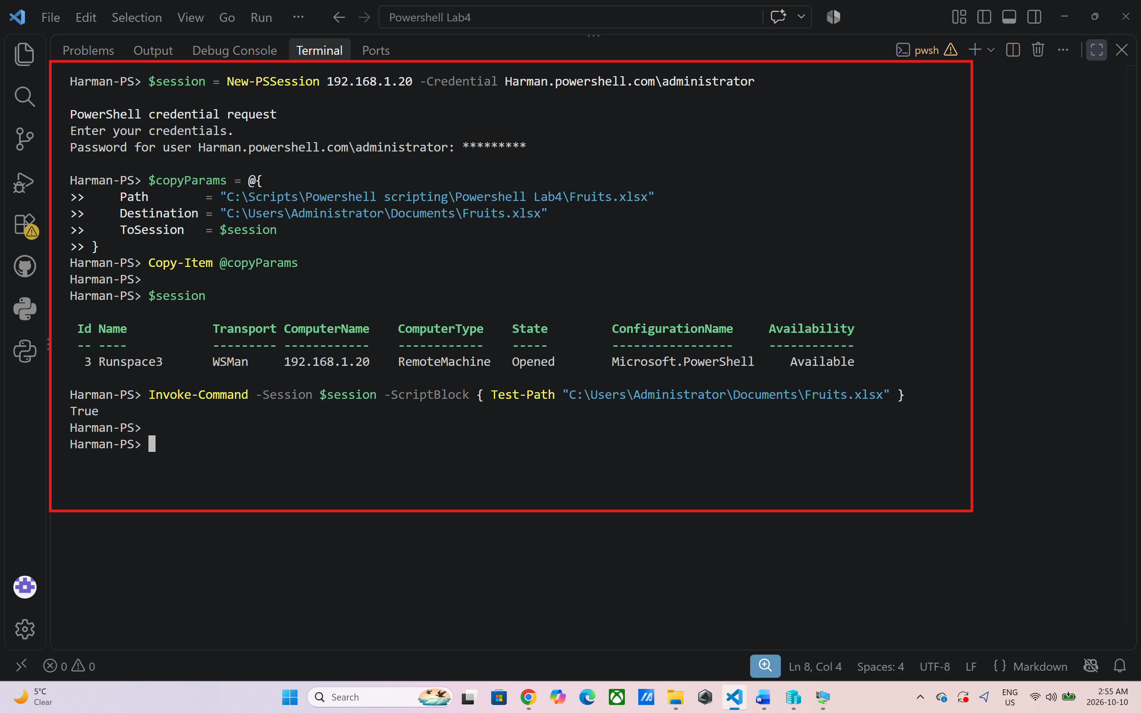
Output: First, I downloaded Fruits.xlsx from Slate and saved it in my Lab 4 folder. Next, I created a hashtable called $copyParams to store the information which needed to copy the file. Path is the file's current location, Destination is where I want to save it on the server, and ToSession tells PowerShell which remote session to use. The command Copy-Item @copyParams copies the file to the server. The @ symbol allows PowerShell to use the values in the hashtable as command parameters. Then, I save the session in a variable and To check the result, I enter $session and look for State: Opened. Then Invoke-Command runs Test-Path on the server to check whether the file exists. A result of True means the file was found at the specified location.

Step 3: Log In to the Server
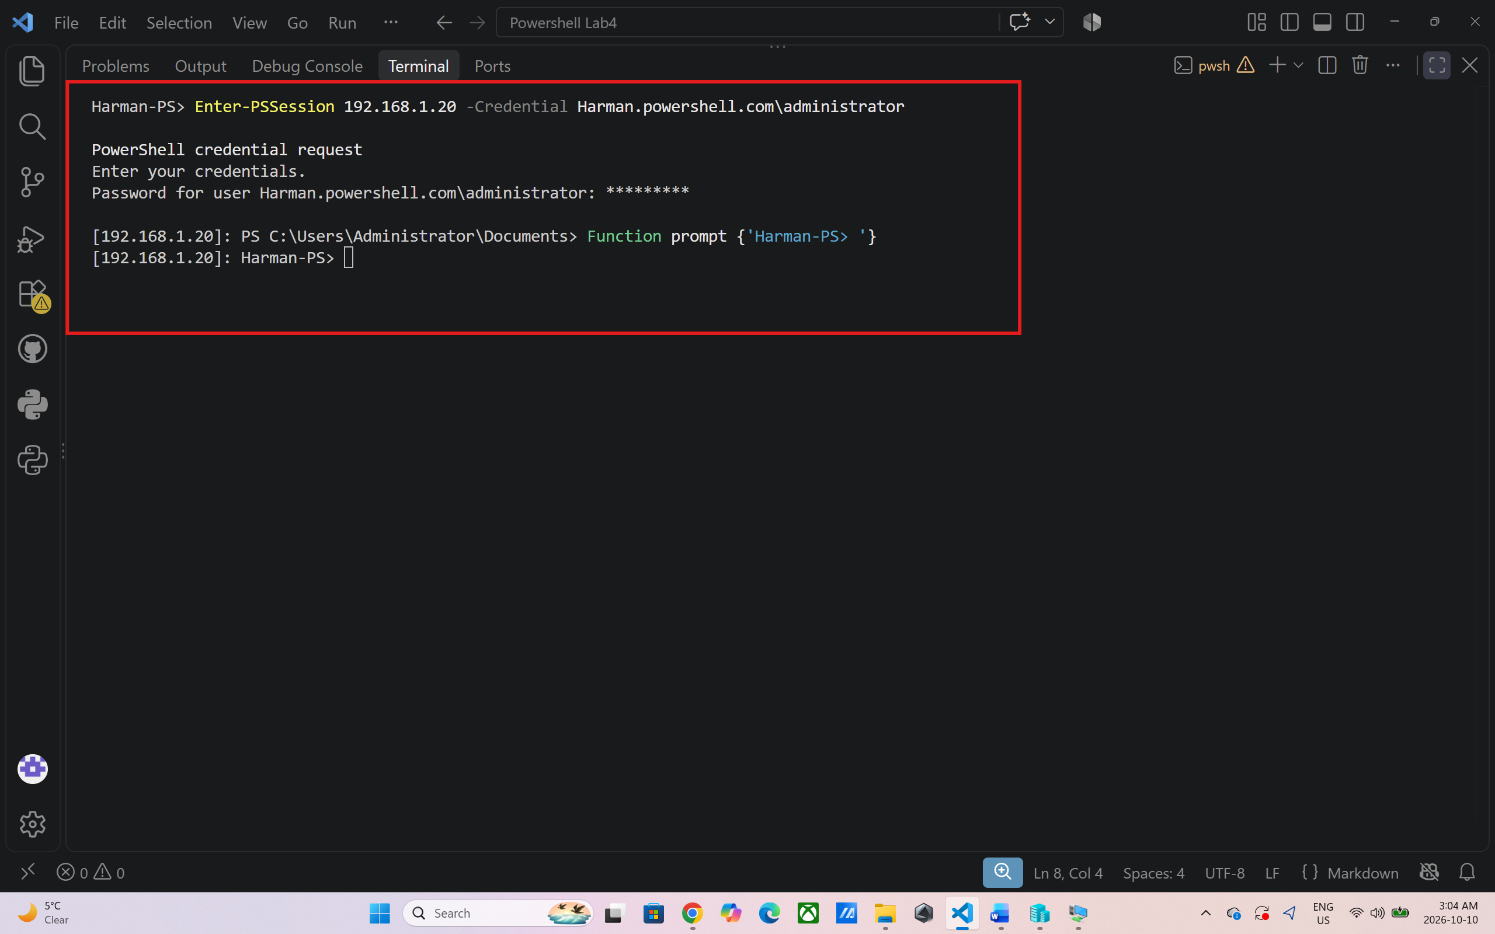
Output: This Command tells me that I am working on the remote server. I am successfully connected to the server for the next steps of the lab.

Step 4: Import Data from Excel
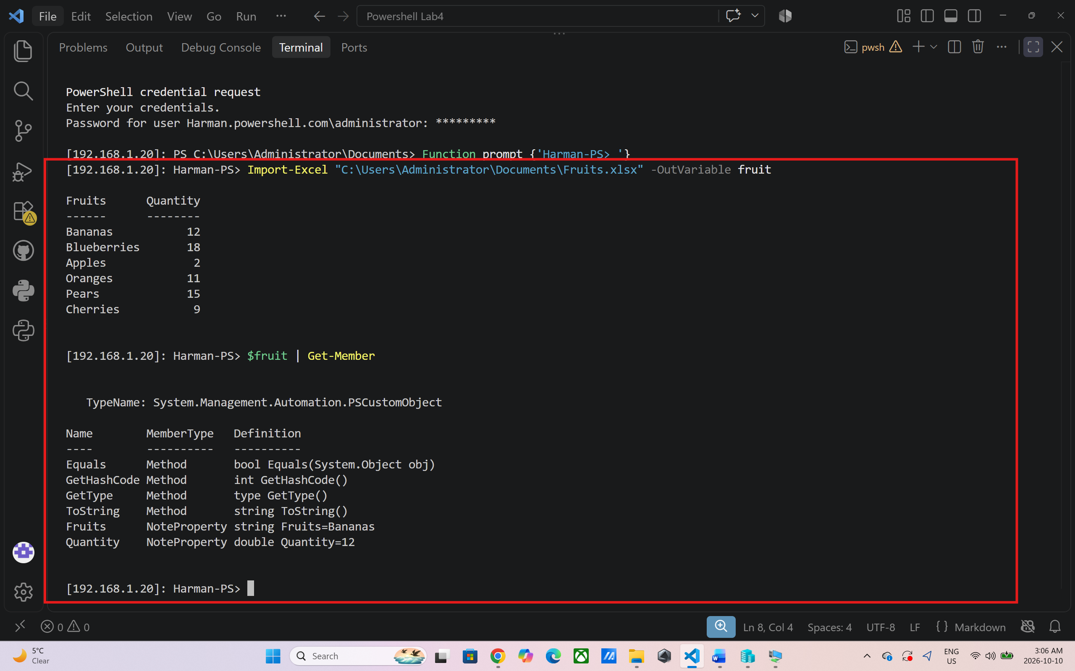
Output: Import-Excel reads the data from Fruits.xlsx and brings it into PowerShell. I used -OutVariable fruit so the imported data is also saved in a variable called $fruit. Get-Member shows the type of data stored in the variable and the properties it contains. This helps me understand what information is available in the imported data. The first command will print the fruit data from the spreadsheet as well as the names of the rows and columns. The column names will be required later when creating the chart. The Get-Member output shows that each row is a TypeName: System.Management.Automation.PSCustomObject. It also displays two NoteProperty entries, these being the two columns of the spreadsheet. The other entries (Equals, GetHashCode, GetType, ToString) are common object methods.

Step 5: Export Data to Excel
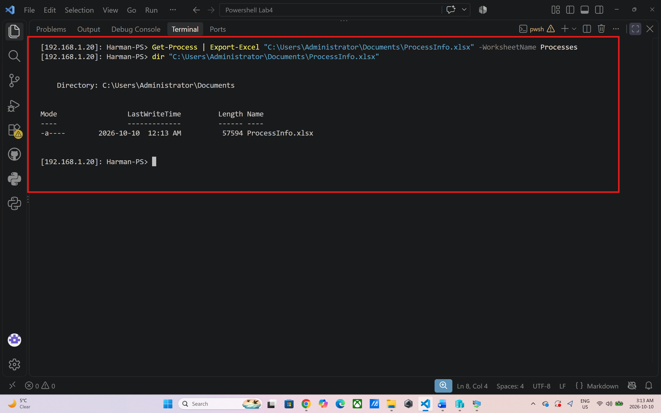
Output: I wanted to export a larger amount of data, so I used Get-Process to collect information about the processes running on the server. The pipe symbol (|) sends this information to Export-Excel, which saves it in a new Excel file called ProcessInfo.xlsx.The process information has numerous properties, hence there are a lot of columns in the spreadsheet. In the next step, I only choose the columns that I want. I named the worksheet Processes with the worksheet name Processes. This parameter was not specified in the lab instructions, but Step 6 requires a worksheet named this parameter. When you add it, the two steps will work together. Excel usually does not display a message when it successfully saves the file. The dir command shows the ProcessInfo.xlsx file, along with its size and creation time. This helps me confirm that the file was created.

Step 6: Import Only Some Columns and Rows
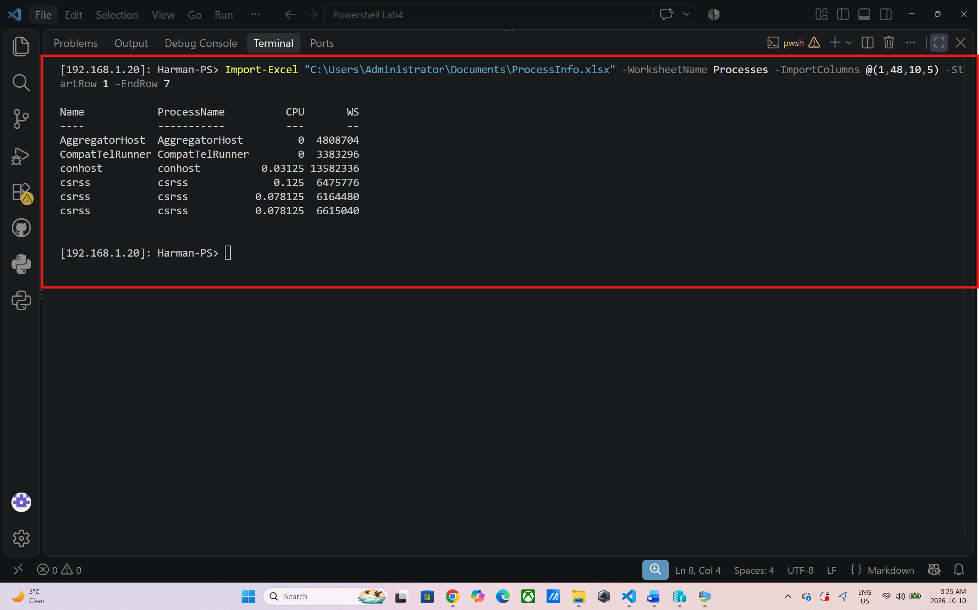
Output: I'm using more columns and rows in the spreadsheet than I need, so I selected certain columns/rows using Import-Excel. I wanted the columns Name, ProcessName, CPU and memory (I used WS, the working set), plus 6 rows of data. The -WorksheetName Processes parameter tells PowerShell which worksheet to read, and -ImportColumns lets me pick columns by number, counting from left to right starting at 1. The lab’s numbers (1,46,12,6) gave me the wrong columns on my file, so I listed my own columns with their numbers and used 1,48,10,5. The columns come out in the order I wrote the numbers. -StartRow 1 and -EndRow 7 tell PowerShell which rows to read. Row 1 is the column headings, so rows 1 to 7 give me the headings plus 6 rows of data. The result is a small table with just four columns and 6 rows instead of the whole spreadsheet.

Step 7: Add Data to an Existing Spreadsheet
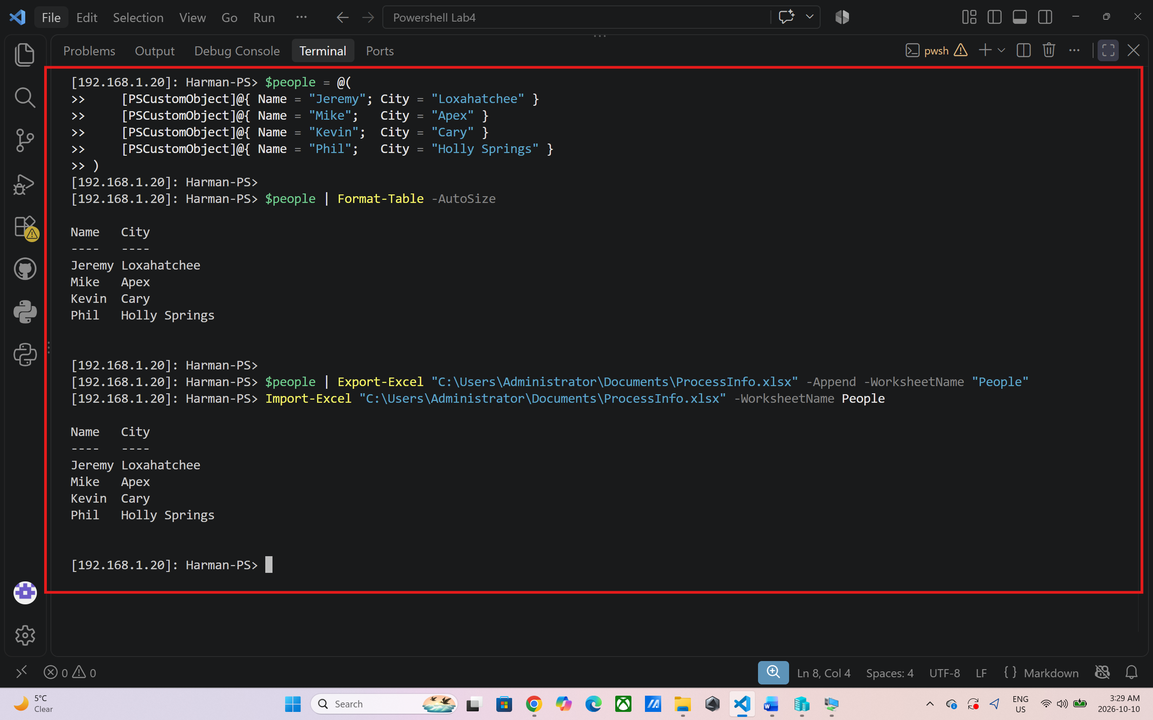
Output: My first step was to make a little table with four people and their cities. The [PSCustomObject] block represents one object, each containing a Name and City. The @() syntax puts the four objects into an array, which is stored in $people. The Format-Table -AutoSize option shows the information in a nice table for inspection before exporting. Then, I added the people data to the ProcessInfo.xlsx file using Export-Excel. The -Append parameter allows me to append the data to the existing file; the -WorksheetName "People" parameter puts the data on a sheet named "People. I could replace the file without -Append and loose the Processes worksheet. The Name and City columns are formatted to display in four rows with Format-Table. Typically, the export command will not generate any output if successful. I then imported the People worksheet using Import-Excel. The same four persons appear in the output which tells that the data was added and can be read back.

Step 8: Export Data with Formatting
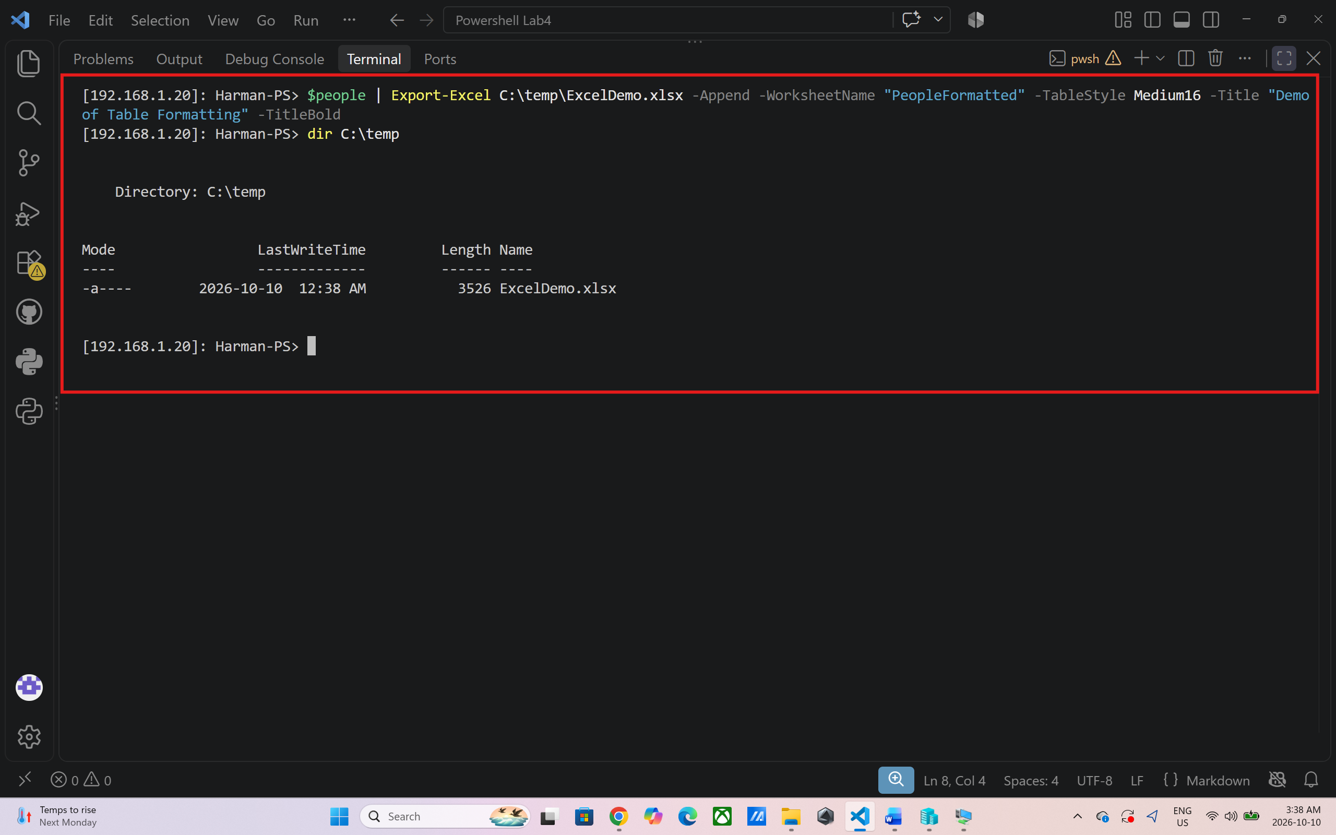
Output: In this step, I have exported a more organized spreadsheet rather than a simple line-by-line export as this would be impossible to use for the purposes of this process. If it is not present, New-Item will create the folder C:\temp. If the folder exists, the -Force parameter is used to prevent an error. The export command also takes the following arguments: -TableStyle Medium16: apply a built-in Excel table style, and -Title: apply a heading above the table, which is also applied using -TitleBold to make the heading bold. These were a few of the formatting options I used in the ImportExcel module, but there are more. Typically, the export command doesn't output a message. I have to open the spreadsheet to find out the answer. You should have a PeopleFormatted sheet with a title that is bolded and above a properly formatted table.

Step 9: Create a Chart
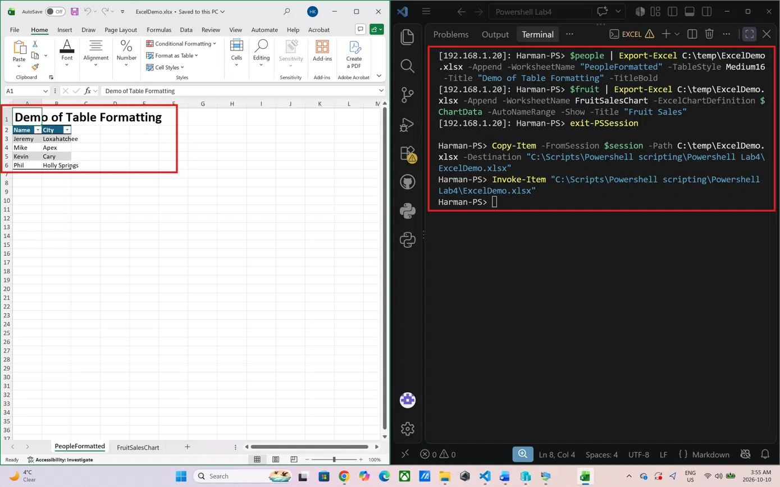

FruitSalesChart:
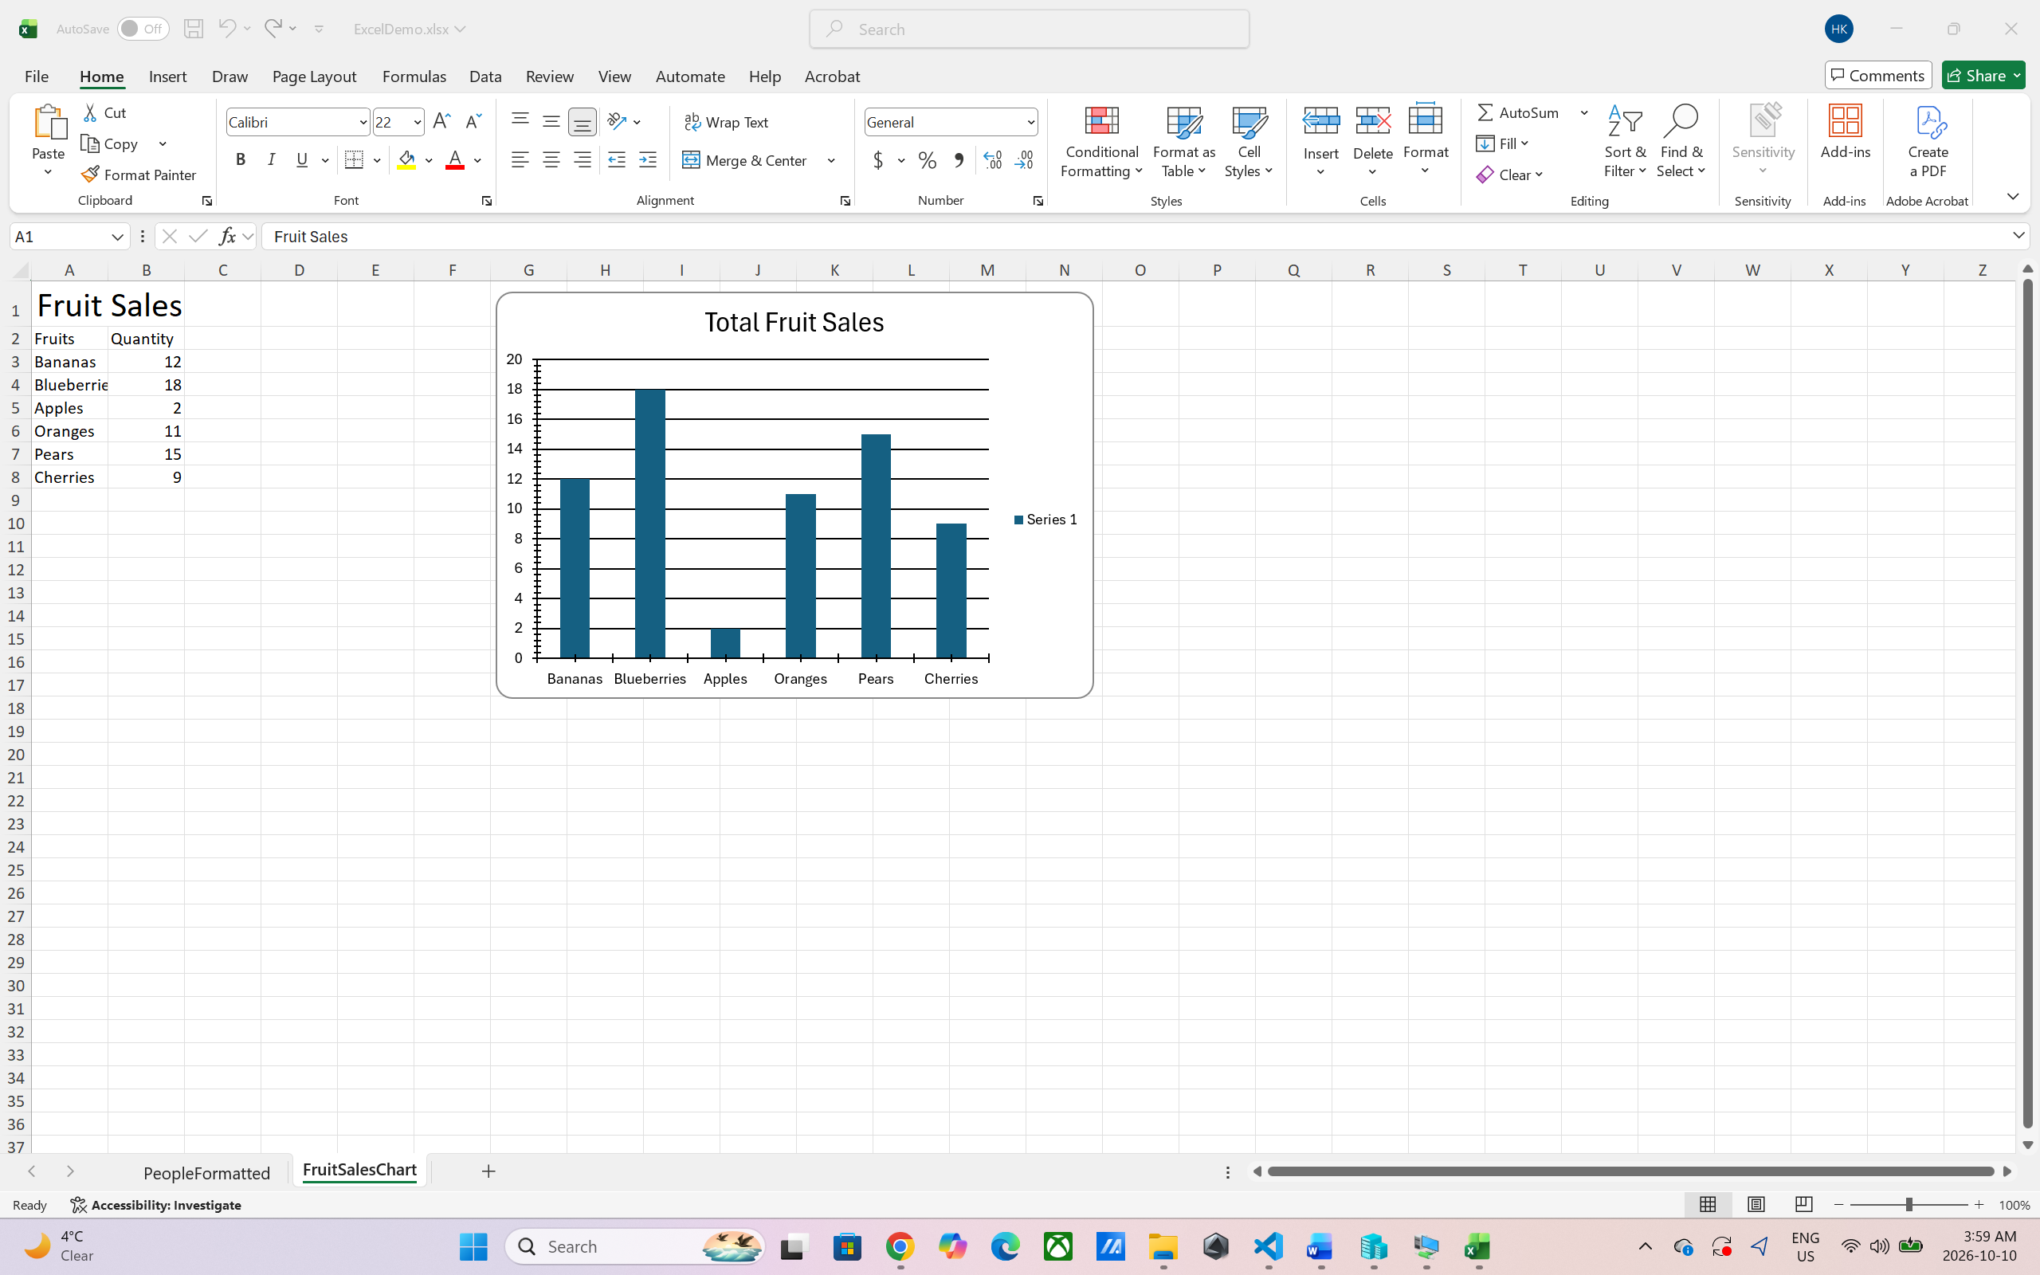

Output: New-ExcelChartDefinition just stored the chart settings in $ChartData, and Export-Excel did not print anything, which means that it worked. Since -Show attempts to open Excel on the server, nothing was displayed on my screen, therefore I closed the remote session, and then I copied ExcelDemo.xlsx back to my Lab 4 folder, then I opened it up on my own computer. The file has a new worksheet called FruitSalesChart. It has the word “Fruit Sales” at the top followed by the table of fruits and quantity: Bananas 12, Blueberries 18, Apples 2, Oranges 11, Pears 15, Cherries 9. A column chart entitled “Total Fruit Sales” is seen next to the table. It's divided into one column for every fruit and has fruit names on the bottom and quantities by the side. The table and the chart are the same in that Blueberries are the tallest and Apples are the shortest. The legend “Series 1” is due to lack of a series name.

Reflection:
This lab allowed me to learn how to utilize the ImportExcel module to read and write Excel files from PowerShell without even needing to install Excel on my server, which is very helpful. When I imported a table into PowerShell, each row was expanded to the form of a PSCustomObject, so it can be sorted and filtered like any other PowerShell data. I exported the running processes to a large spreadsheet; then imported just the columns and rows I wanted, added a new tab called People, formatted a table with a style, added a bold title, and created a column chart of the fruit data with -Append. I also had some remote sessions using New-PSSession, Enter-PSSession and Copy-Item and I watched how to publish a project to GitHub from VS Code. There were a lot of problems, mostly arising from non-matching lab instructions with my machine. While running, my terminal opened in the wrong folder, and the space in Power Shell script made the copy path only recognized within quotes. There were also a few minor errors in the lab: -ImportColumns didn't have a space before the @, the Enter-PSSession line had an extra ' at the end, and the code block was never closed. I renamed the worksheet as Processes in order to provide it with the export command. I got the column numbers 1,46,12,6 and received the details of the PrivateMemorySize64 and ProductVersion instead of ProcessName and CPU, since the order of those columns is different in my file. I put the numbers of my own columns and used 1,48,10,5. Also I got warnings for the chart command, but no chart; and the command used the column names Item and TotalSold when my table has the column names Fruits and Quantity. I resolved this by using $fruit and my actual column names. There were a few things that I did wrong too. I made a typo in the title; I then ran the export again, and PowerShell complained that -Title doesn't work when appending. I had to delete ExcelDemo.xlsx with Remove-Item and run the commands again to get a clean file as the data was added again. Since -Show will try to open Excel on the server, nothing appeared on my screen, so I closed the session and copied the file back to my computer and opened it on my computer. The first screenshots were with spaces and a capital .Png were not showing up as images on GitHub, and I renamed them to lowercase with dashes in a screenshots folder so that they would. The key lessons were to read warnings and errors carefully; each warning or error revealed something real to me, and not to trust column numbers or variable names from instructions without verifying them with my data.

